

NOVAC TECHNOLOGY SOLUTIONS

User Manual

Document Version No.: 1.00

Revision History
Version No | Reason For Changes | Author | Approver
0.01 | Draft | Anurag Kumar
1.00 | Reviewed & Approved the User Manual | Anurag Kumar | NIJANTHAN PL

Table of Contents
1. Introduction 4

2. Warrantee Clause Interface 4

Introduction

The system should have the facility to view and download the warrantee clauses based on the input parameter.

Warrantee Clause Interface

- System should have the provision to filter the warrantee clauses based on the product wise. Refer the below sample screen for Warrantee clauses view.

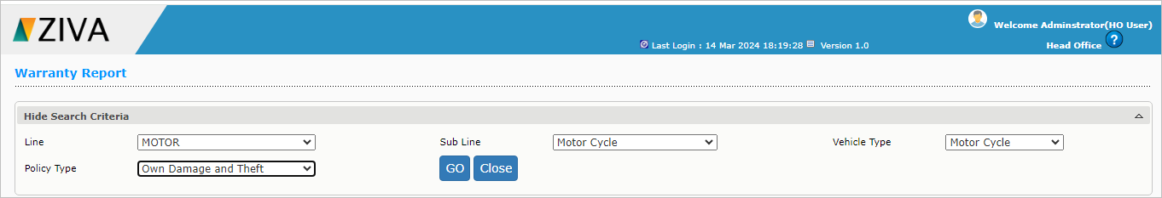

Click on Go button to view the entire clause in the dashboard & then click on the download button to download the clause in PDF.

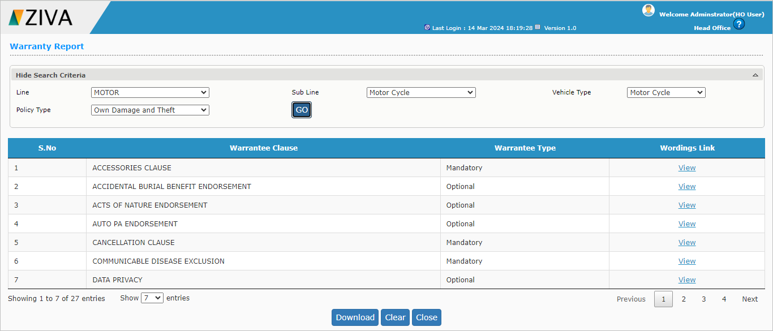

After downloading the clause click on close button to close the window.

